Jacqueline would love to share her career achievements and her expert knowledge in the Wedding and Event industry at your next conference or workshop. Her signature speaking style will leave your attendees inspired and wanting to hear more.

Available as Speaker for Keynote, Workshop, Breakout Session, Seminar, TV/Radio Industry Expert, or Panelist.

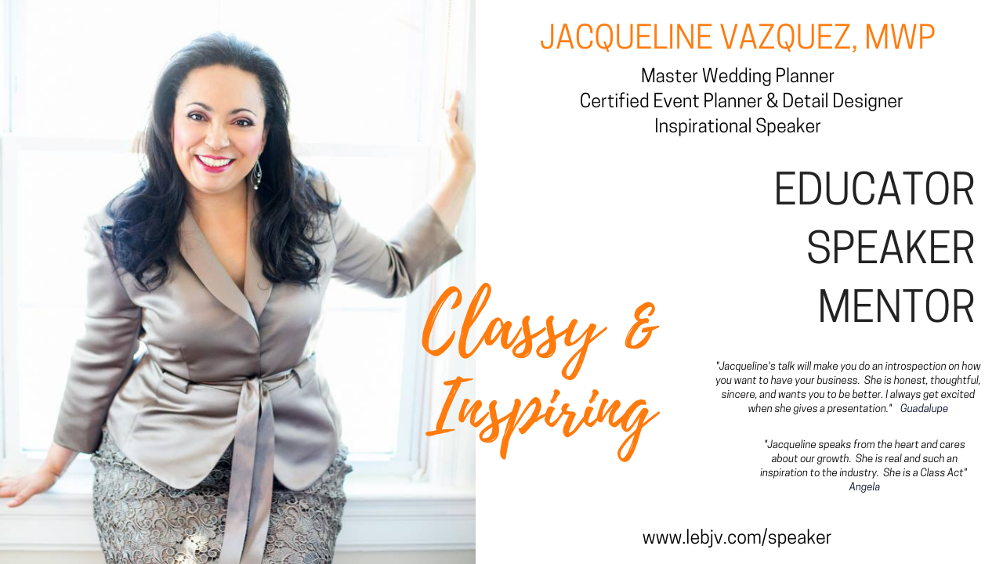

Speaker – Educator Media Kit
